UNIVERSITY MANAGEMENT SYSTEM



DATABASE MANAGEMENT SYSTEM PROJECT REPORT

By

KOSIKA DHEERAJ REDDY

21MEB0A35

K.NAGA RITVIK

PROBLEM STATEMENT:

A university wants to create a database system to manage its operations effectively. The system should track information about subjects, professors, students, books, and departments. The following problem statement outlines the requirements for the database system:

Departments: The university has multiple departments identified by a unique department ID. Each department has a name, a head of department (HOD) name, and contact information (HOD phone number).

Students: Students are registered in the university and have access to the library. Each student has a unique student ID and is identified by their name, email, phone number, date of birth, and gender. Students are associated with a specific department.

Books: The library maintains a collection of books that can be borrowed by students. Each book has a unique book ID, a name, and a date of borrowing. The book is associated with the student who borrowed it.

Subjects: The department offers various subjects, each identified by a unique subject ID. Each subject has a name and is associated with a department.

Professors: Professors teach subjects at the university. Each professor has a unique professor ID and is associated with a subject, department, and contact information (phone number). Professors are identified by their names.

The database system should allow the following operations:

Add new subjects, professors, students, books, and departments to their respective tables.

Update information for existing subjects, professors, students, books, and departments.

Retrieve information about subjects, professors, students, books, and departments.

Delete subjects, professors, students, books, and departments from the database if necessary.

The database system should enforce the following relationships:

Professors are associated with a subject and a department. The subject ID and department ID in the PROFESSOR table should reference the corresponding IDs in the SUBJECTS and DEPARTMENT tables, respectively.

Books are associated with a student. The student ID in the BOOKS table should reference the corresponding ID in the STUDENT table.

Students are associated with a department. The department ID in the STUDENT table should reference the corresponding ID in the DEPARTMENT table.

The university management system aims to provide efficient tracking and management of subjects, professors, students, books, and departments. By maintaining this database, the library can easily manage borrowing records, professor assignments, student information, and departmental details, ensuring smooth operations within the university library environment.

ER DIAGRAM:

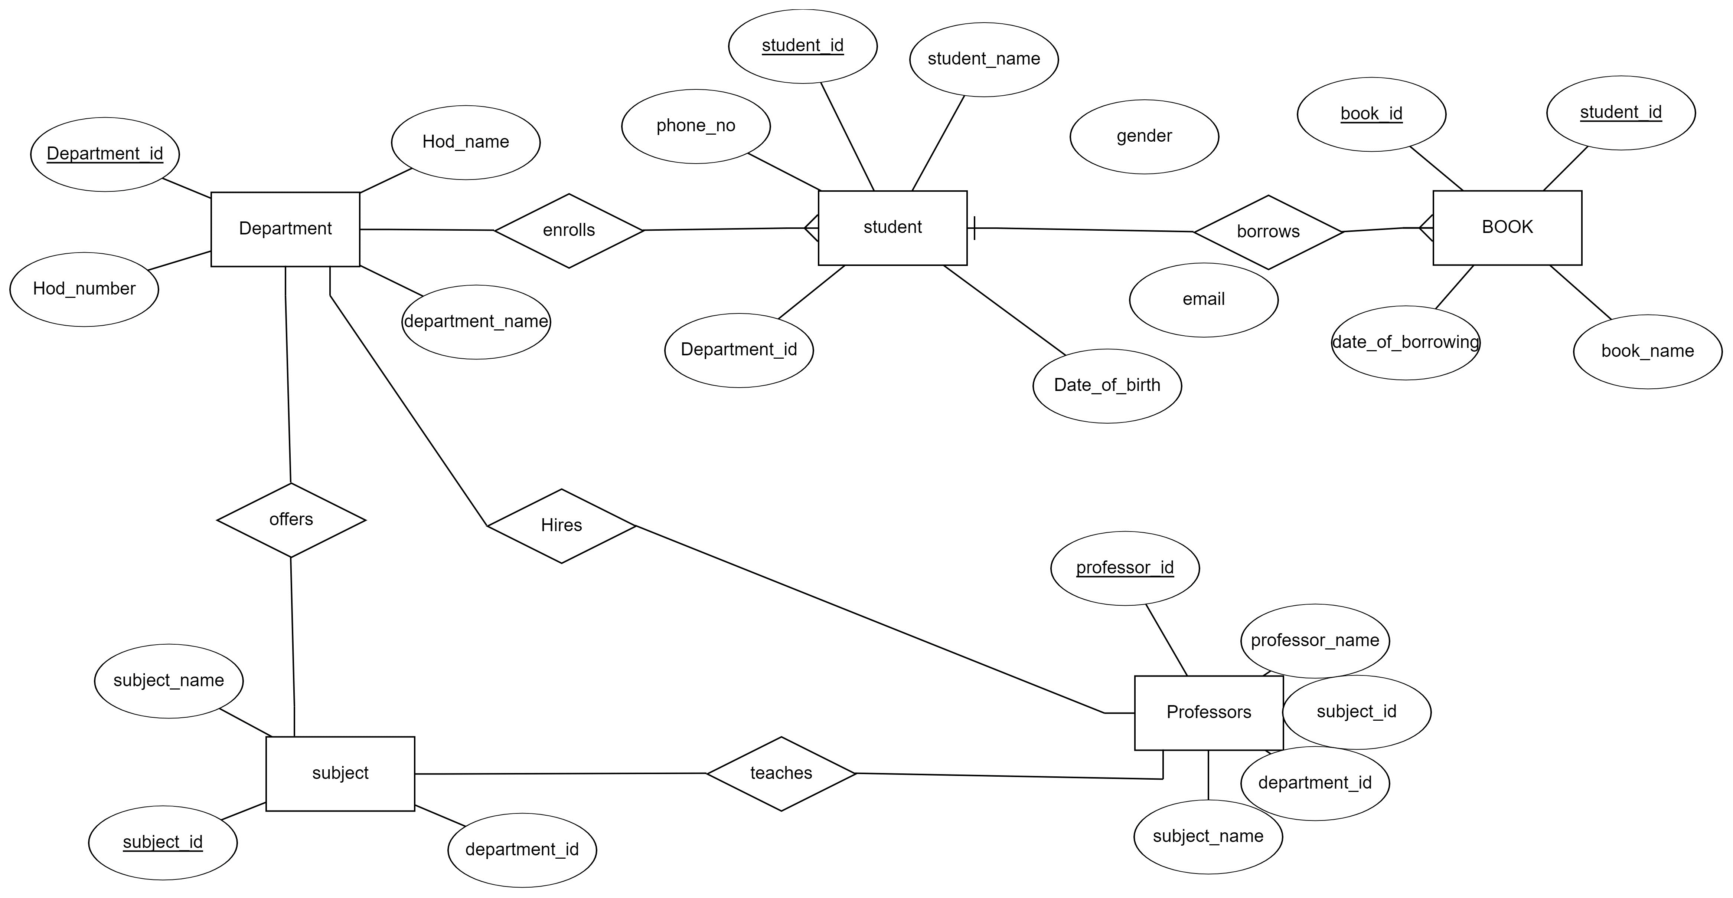

TABLES:

1)DEPARTMENT TABLE:

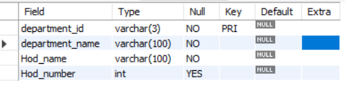

2)STUDENT TABLE

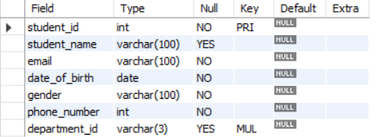

3)BOOKS TABLE:

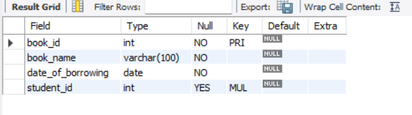

4)SUBJECTS TABLE:

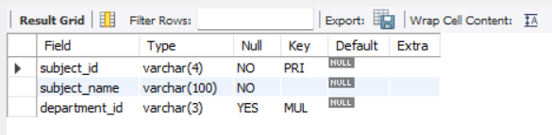

5)PROFESSOR TABLE:

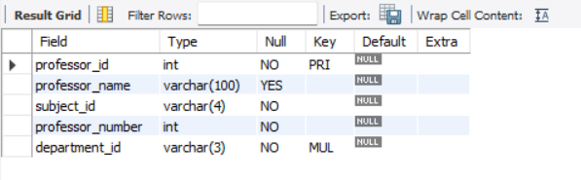

FUNCTIONAL DEPENDENCIES AND PRIMARY KEYS:

* In the STUDENT table, we have the following functional dependencies:

STUDENT_ID -> EMAIL, PHONE_NUMBER, STUDENT_NAME,

DATE_OF_BIRTH, GENDER.

* In the BOOKS table, we have the following functional dependencies:

BOOK_ID -> BOOK_NAME, DATE_OF_BORROWING STUDENT_ID -> [no functional dependencies]

* In the DEPARTMENT table, we have the following functional dependencies:

DEPARTMENT_ID -> DEPARTMENT_NAME, HOD_PHONE_NO, HOD_NAME.

* In the PROFESSOR table, we have the following functional dependencies: PROFESSOR_ID -> SUBJECT_ID, PHONE_NUMBER, NAME, DEPARTMENT_ID
* In the SUBJECTS table, we have the following functional dependencies: SUBJECT_ID -> SUBJECT_NAME, DEPARTMENT_ID

ASSUMPTIONS:

1. Every student must enroll in a department and can enroll in only one department.
2. Students enrolled in a department must study all the subjects offered by the particular department.
3. Students can take more than one book at a time.

NORMALIZATION INTO HIGHER FORMS:

The three normal forms commonly referred to in database normalization are:

First Normal Form (1NF):

The first normal form requires that each column in a table contain only atomic values, meaning that each value should be indivisible. It eliminates repeating groups and ensures that each column has a single value. In 1NF, a table should have a primary key that uniquely identifies each row.

Second Normal Form (2NF):

The second normal form builds upon the first normal form. It states that a table should meet 1NF requirements and that all non-key attributes (columns) should be fully functionally dependent on the entire primary key. In other words, if a table has a composite primary key (multiple columns), each non-key column should depend on the entire composite key, not just a part of it. If a non-key column depends on only a portion of the primary key, it should be moved to a separate table. Third Normal Form (3NF):

The third normal form goes further by eliminating transitive dependencies. It states that a table should meet the requirements of 2NF and that no non-key attribute should depend on another non-key attribute. In simpler terms, all non-key columns should be functionally dependent only on the primary key. If a non-key column depends on another non-key column, it should be moved to a separate table.

By following the normalization process and achieving higher normal forms, databases can minimize redundancy, improve data integrity, and simplify data maintenance and updates. Our table is already in Normalized form.

QUERIES FOR TABLE CREATION:

1.

create table department(

department_id VARCHAR(3) PRIMARY KEY,

department_name VARCHAR(100) NOT NULL,

Hod_name VARCHAR(100) NOT NULL,

Hod_number INTEGER

)

2.

create table student(

student_id integer PRIMARY KEY,

student_name VARCHAR(100),

email VARCHAR(100) NOT NULL,

date_of_birth date NOT NULL,

gender VARCHAR(100) NOT NULL,

phone_number INTEGER NOT NULL,

department_id VARCHAR(3),

foreign key(department_id) references department(department_id) on delete set Null

)

3.

create table books(

book_id integer PRIMARY KEY,

book_name VARCHAR(100) NOT NULL,

date_of_borrowing date NOT NULL,

student_id int,

foreign key(student_id) references student(student_id) on delete set Null

)

4.

create table subjects(

subject_id varchar(4) PRIMARY KEY,

subject_name VARCHAR(100) NOT NULL,

department_id VARCHAR(3),

foreign key(department_id) references department(department_id) on delete set Null

)

5.

create table professor(

professor_id integer PRIMARY KEY,

professor_name VARCHAR(50),

subject_id varchar(4) NOT NULL,

professor_number INTEGER NOT NULL,

department_id VARCHAR(3) NOT NULL,

foreign key(department_id) references department(department_id) on delete set Null

)

INSERTING RANDOM DATA:

1. INSERTING DEPARTMENT TABLE

INSERT INTO department (department_id, department_name, Hod_name, Hod_number)

VALUES

    ('cse', 'Computer Science', 'prof.Dheeraj reddy', 123456),

    ('eee', 'Electrical Engineering','prof.Dhanush ', 987654),

    ('me', 'Mechanical Engineering', 'Prof.Ritvik', 654321),

    ('ce', 'Civil Engineering', 'Prof.Dattu srivastav', 567890);

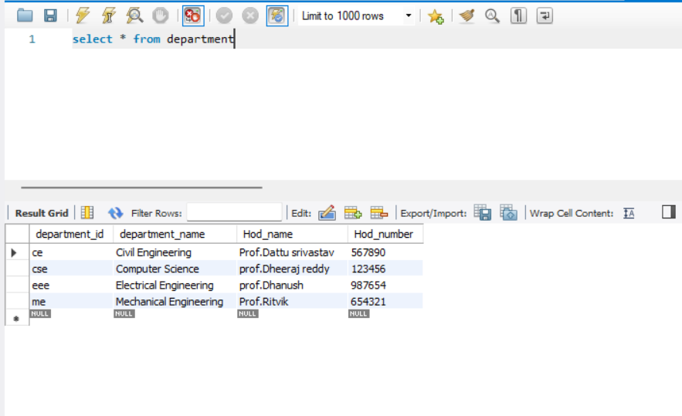

2. INSERTING STUDENT TABLE

INSERT INTO student (student_id, student_name, email, date_of_birth, gender, phone_number, department_id)

VALUES

    (1, 'anirudh', 'ani@example.com', '2000-01-01', 'male', 12345690, 'me'),

    (2, 'harsha', 'harsh@example.com', '2001-02-02', 'male', 34577890, 'me'),

    (3, 'srinivas', 'srn@example.com', '1989-03-03', 'male', 234501, 'cse'),

    (4, 'shiva', 'siv@example.com', '2000-04-04', 'male', 8901567, 'eee'),

    (5, 'latha', 'latha@example.com', '1993-05-05', 'female', 3459012, 'cse'),

    (6, 'sophia', 'sophi@example.com', '2000-06-06', 'female', 745678, 'me'),

    (7, 'David', 'davi@example.com', '2001-07-07', 'male', 4890123, 'eee'),

    (8, 'Olivia', 'olivia@example.com', '1999-08-08', 'female', 0456789, 'me'),

    (9, 'ram', 'ram@example.com', '2002-09-09', 'male', 999999, 'cse'),

    (10, 'sita', 'sita@example.com', '2003-10-08', 'female', 55555, 'eee'),

    (11, 'varaprasad', 'vara@example.com', '2003-03-19', 'male', 654387, 'ce'),

    (12, 'Chaitanya', 'chaithu.davis@example.com', '2000-07-05', 'female', 876109, 'ce'),

    (13, 'williamson', 'willi@example.com', '2002-01-16', 'male', 987510, 'eee'),

    (14, 'misty', 'misty@example.com', '2001-11-22', 'female', 543876, 'me'),

    (15, 'steven', 'smith@example.com', '2003-05-08', 'male', 2109876543, 'ce');

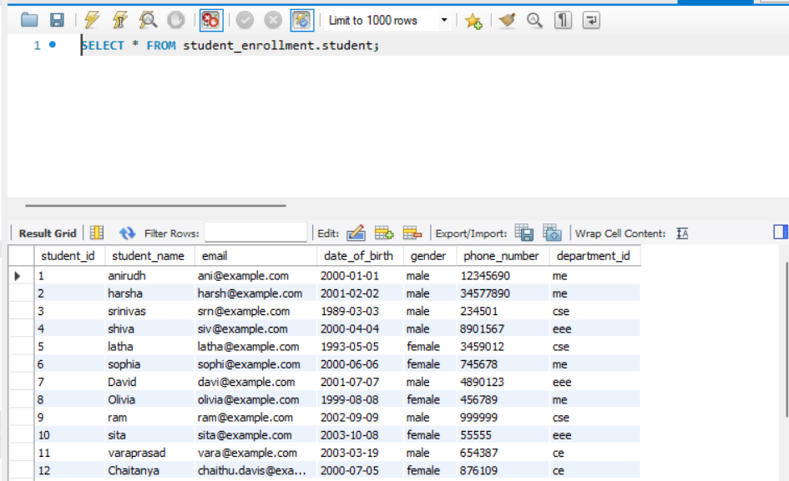

3. INSERTING BOOK TABLE

INSERT INTO books (book_id, book_name, date_of_borrowing, student_id)

VALUES

    (1, 'Introduction to Programming', '2023-06-15', 1),

    (2, 'Electric Circuits', '2023-07-02', 2),

    (3, 'Database Management Systems', '2023-06-28', 3),

    (4, 'Digital Electronics', '2023-07-10', 4),

    (5, 'Data Structures and Algorithms', '2023-06-20', 5),

    (6, 'Mechanical Engineering Principles', '2023-07-05', 6),

    (7, 'Power Systems', '2023-07-03', 6),

    (8, 'Computer Networks', '2023-06-25', 7),

    (9, 'Artificial Intelligence', '2023-06-29', 8),

    (10, 'Control Systems', '2023-07-12', 8),

    (11, 'Structural Analysis', '2023-07-08', 9),

    (12, 'Transportation Engineering', '2023-07-01', 9),

    (13, 'Electromagnetic Theory', '2023-06-23', 10),

    (14, 'Machine Learning', '2023-06-27', 10),

    (15, 'Hydraulics', '2023-07-06', 10),

    (16, 'Operating Systems', '2023-06-30', 1),

    (17, 'Renewable Energy Systems', '2023-07-04', 2),

    (18, 'Web Development', '2023-06-26', 13),

    (19, 'Geotechnical Engineering', '2023-07-07', NULL),

    (20, 'Computer Architecture', '2023-07-09', NULL);

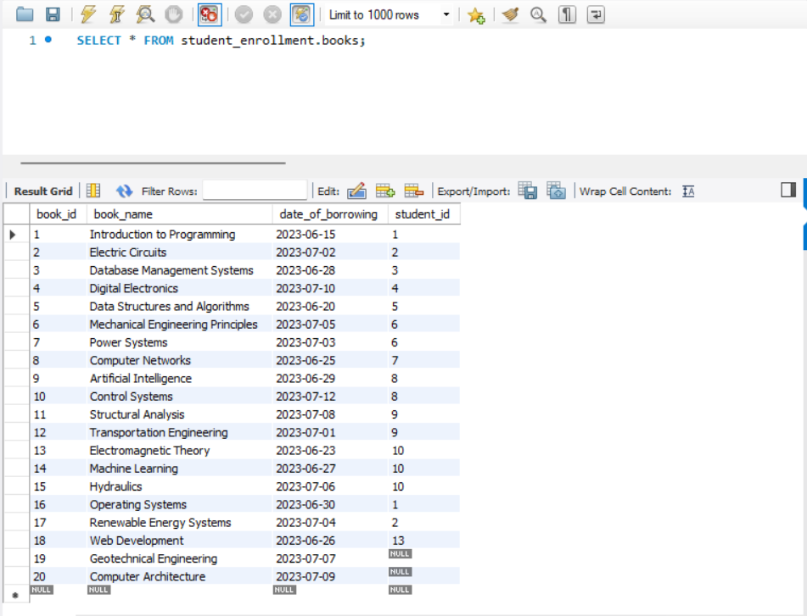

4. INSERTING SUBJECT TABLE

INSERT INTO subjects (subject_id, subject_name, department_id)

VALUES

    ('cs01', 'Introduction to Computer Science', 'cse'),

    ('cs02', 'Data Structures and Algorithms', 'cse'),

    ('cs03', 'Database Management Systems', 'cse'),

    ('cs04', 'Software Engineering', 'cse'),

    ('cs05', 'Digital Electronics', 'cse'),

    ('ee01', 'Power Systems', 'eee'),

    ('ee02', 'Control Systems', 'eee'),

    ('ee03', 'Signal Processing', 'eee'),

    ('me01', 'Thermodynamics', 'me'),

    ('me02', 'Mechanics of Materials', 'me'),

    ('me03', 'Fluid Mechanics', 'me'),

    ('me04', 'Manufacturing Processes', 'me'),

    ('ce01', 'Structural Analysis', 'ce'),

    ('ce02', 'Transportation Engineering', 'ce'),

    ('ce03', 'Geotechnical Engineering', 'ce'),

    ('ce04', 'Environmental Engineering', 'ce'),

    ('ee04', 'power electronics', 'eee'),

    ('me05', 'Machine design', 'me'),

    ('ee05', 'Electrical Networking', 'eee'),

    ('ce05', 'material engineering', 'ce');

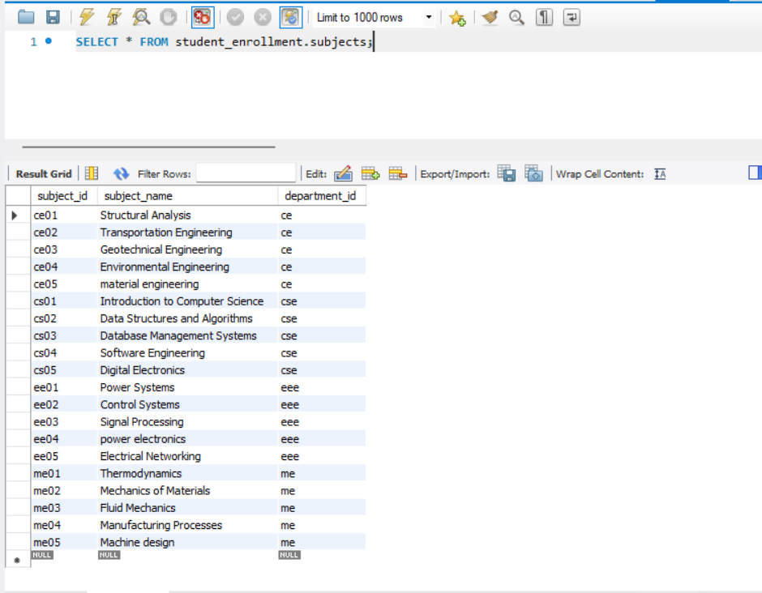

1. INSERTING PROFESSOR TABLE

INSERT INTO professor (professor_id, professor_name, subject_id, professor_number, department_id)

VALUES

    (1, 'Johnson', 'cs01', 123456, 'cse'),

    (2, 'steve smith', 'cs02', 234567, 'cse'),

    (3, 'virat kumar', 'cs03', 345678, 'cse'),

    (4, 'mahindra singh', 'cs04', 456789, 'cse'),

    (5, 'virendra singh', 'ee01', 567890, 'eee'),

    (6, 'rahul sitaraman', 'ee02', 678901, 'eee'),

    (7, 'David wills', 'ee03', 789012, 'eee'),

    (8, 'Olivia ', 'me01', 890123, 'me'),

    (9, 'Williamson', 'me02', 901234, 'me'),

    (10, 'Sophia Antony', 'ce01', 123456, 'ce'),

    (11, 'Jimmy Johnson', 'ce02', 234567, 'ce'),

    (12, 'Thompson', 'cs05', 345678, 'cse'),

    (13, 'Liam Wilson', 'ee04', 456789, 'eee'),

    (14, 'Cornwall', 'me03', 567890, 'me'),

    (15, 'Benjamin Anderson', 'ce03', 678901, 'ce'),

    (16, 'Amelia slater', 'ce04', 789012, 'ce'),

    (17, 'Henry Davis', 'ee05', 890123, 'eee'),

    (18, 'Tyson steel', 'me04', 901234, 'me'),

    (19, 'Alexander bell', 'ce05', 123456, 'ce'),

    (20, 'elva Thompson', 'me05', 234567, 'me');

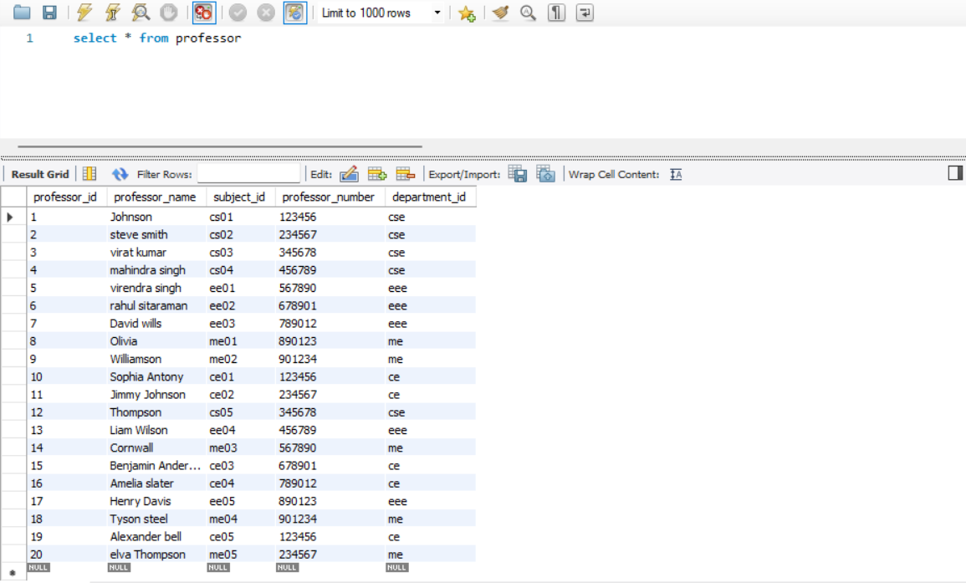

SQL QUERIES:

1. QUERY TO RETURN INFORMATION OF PROFESSORS IN A DEPARTMENT:

select * from professor

where professor.department_id='me';

1. 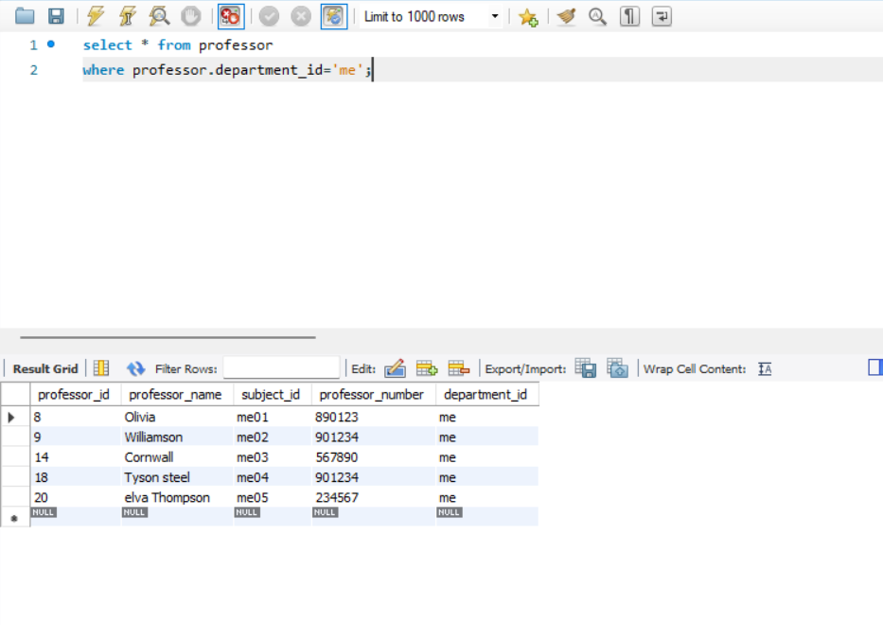

2.QUERY TO RETURN SUBJECTS OFFERED AND PROFESSORS TEACHING THE COURSE:

select subjects.subject_id,subjects.subject_name,professor.professor_id,

professor.professor_name,professor.department_id

from subjects

join professor on professor.subject_id=subjects.subject_id

order by subject_id asc;

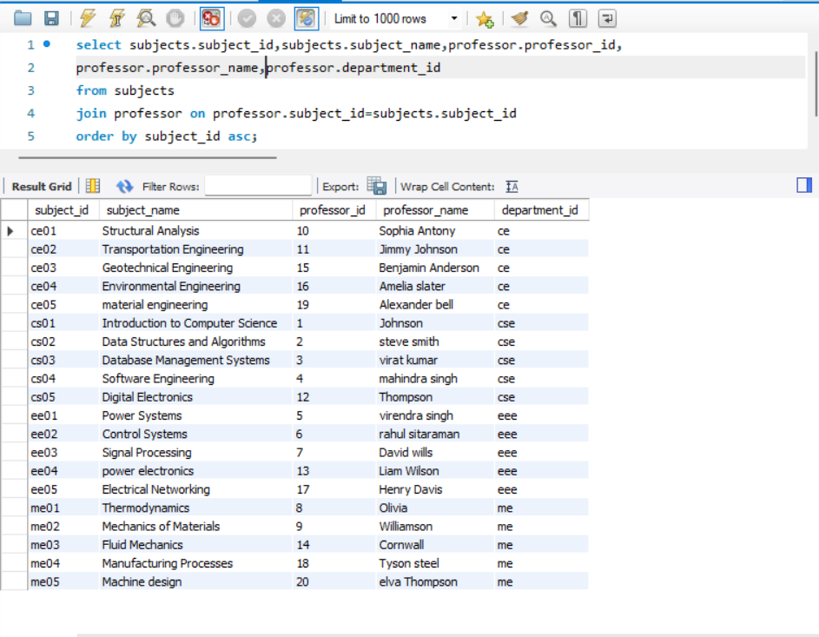

1. query to retrieves the information related to a specific student like name, the subjects they are enrolled in, the corresponding professors for those subjects, the department name, and the name of the Head of the Department (HOD).

Select student.student_name,subjects.subject_id,subjects.subject_name,professor.professor_name,

department.department_name,department.Hod_name

from student

left join subjects on subjects.department_id=student.department_id

left join professor on subjects.subject_id=professor.subject_id

left join department on department.department_id=professor.department_id

where student_id='3'

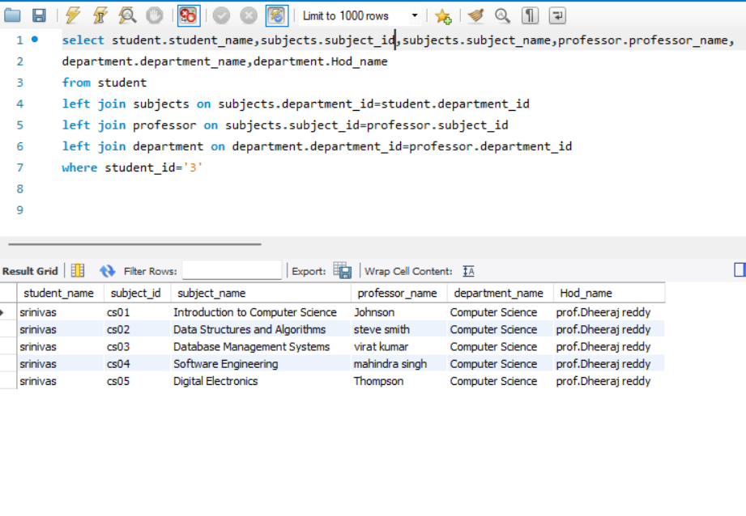

1. Query to return the list of students studying under a particular professor:

SELECT student.student_id, student.student_name, department.department_name

FROM student

JOIN department ON student.department_id = department.department_id

JOIN subjects ON department.department_id = subjects.department_id

JOIN professor ON professor.subject_id = subjects.subject_id

WHERE professor.professor_id='9'

